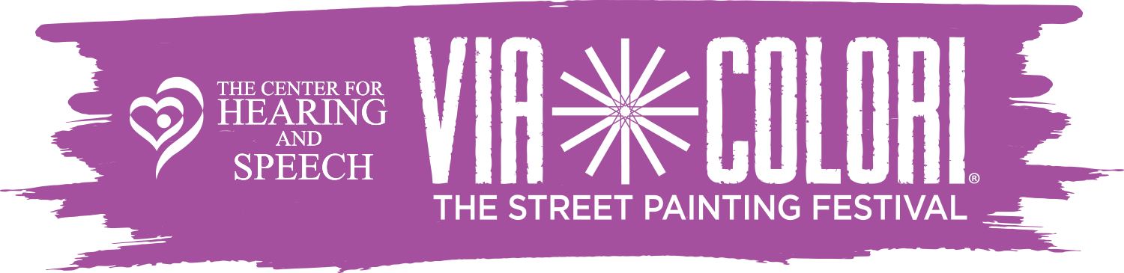
2018 Volunteer Release Form
*Please only use blue/black pen and fill out ALL form criteria

__________________________________________________________________________
Name

__________________________________________________________________________
Address

__________________________________________________________________________
City/State/Zip

__________________________________________________________________________
Phone

__________________________________________________________________________
Email

__________________________________________________________________________
Emergency Contact Name and Phone

_________ I have read the General Volunteer Rules and Information sheet attached.
(Initial)

I hereby agree to RELEASE, INDEMNIFY, SAVE AND HOLD HARMLESS The Center for Hearing and Speech, Via Colori®, and any sponsor of the Event or any other persons or entities associated with the Event of and from any and all losses, claims, damages, demands, liabilities and/or lawsuits for personal injury, property damage or other losses, including any costs, expenses and attorney’s fees, which may in any arise from or in connection with any of the activities and/or responsibilities which I may be involved with as a volunteer of Via Colori, a Street Painting Festival.

I further understand and acknowledge that as a volunteer, I am not an employee of The Center for Hearing and Speech and will not be compensated for my service. I certify that I am in good health and reasonably fit in order to safely participate in Via Colori activities. I also agree to inform the Lead Volunteer of any medication, ailment, condition, or injury that may affect my performance. I agree to act in a reasonable and responsible fashion, and agree that I will not undertake or perform any activities or duties as a volunteer while under the influence of alcohol or drugs. I understand that the Center reserves the right to remove any volunteer who acts inappropriately at the Center’s discretion.

Furthermore, I give my full permission for the Center to photograph me and to use, publish and re-publish photographs or video taken during the festival.

I STATE THAT I HAVE READ, UNDERSTAND AND AGREE TO ALL CONDITONS SET FORTH HEREIN.

Signature ______________________________________________________ Date _________________

